**GRADES: 9-12**

**KEY QUESTIONS:**

* How are wildlife species and communities affected by human activities?
* What makes some species more adaptable to urban life than others?

**LEARNING GOALS:**

After completing this activity, students will be able to:

* Explain the difference between “urban”, “rural”, and “wild” land classifications.
* Quantify an ecological community using species richness.
* Understand the role of survey effort in determining species richness.
* Define an ecological niche and the life history traits of litter size, home range size, and body mass.
* Predict what kinds of species most easily adapt to life in human-dominated areas, based on species life history traits.
* Graph and analyze data in Google Sheets.

**TIME:**

Two 50-minute class periods.

**Day 1:** Familiarize the class with camera trap data and the concept of species

richness.

**Day 2:** Analyze data on species richness

**MATERIALS:**

* Student worksheet: *Life in the City: Using Camera Trap Data to Understand Wildlife Response to Human Development*
* Computers with access to internet and Google Sheets
* Access to the data set, available at

<http://science-live.org/teachers/lifeinthecity.html>

* Website: <http://emammal.si.edu>
* Website: <http://www.inaturalist.org/guides/3098>
* Website: <http://eol.org>
* “Making Bar Graphs in Google Sheets” handout

Throughout this lesson, items in **bold blue font** indicate that students should answer a question on their worksheets.

**Next Generation Science Standards* Addressed:**

*GSS Lead States. 2013. Next Generation Science Standards: For States, By States. Washington, DC: The National Academies Press.

***HS-LS2 Ecosystems: Interactions, Energy, and Dynamics***

HS-LS2-2. Use mathematical representations to support and revise explanations based on evidence about factors affecting biodiversity and populations in ecosystems of different scales.

HS-LS2-6. Evaluate the claims, evidence, and reasoning that the complex interactions in ecosystems maintain relative consistent numbers and types of organisms in stable conditions, but changing conditions may result in a new ecosystem.

HS-LS2-7. Design, evaluate, and refine a solution for reducing the impacts of human activities on the environment and biodiversity

*Disciplinary Core Ideas:*

LS2.A: Interdependent Relationships in Ecosystems

* Ecosystems have carrying capacities, which are limits to the numbers of organisms and populations they can support. These limits result from such factors as the availability of living and nonliving resources and from such challenges such as predation, competition, and disease. Organisms would have the capacity to produce populations of great size were it not for the fact that environments and resources are finite. This fundamental tension affects the abundance (number of individuals) of species in any given ecosystem. (HS-LS2-1),(HS-LS2-2)

LS2.C: Ecosystem Dynamics, Functioning, and Resilience

* A complex set of interactions within an ecosystem can keep its numbers and types of organisms relatively constant over long periods of time under stable conditions. If a modest biological or physical disturbance to an ecosystem occurs, it may return to its more or less original status (i.e., the ecosystem is resilient), as opposed to becoming a very different ecosystem. Extreme fluctuations in conditions or the size of any population, however, can challenge the functioning of ecosystems in terms of resources and habitat availability. (HS-LS2-2),(HS-LS2-6)
* Moreover, anthropogenic changes (induced by human activity) in the environment—including habitat destruction, pollution, introduction of invasive species, overexploitation, and climate change—can disrupt an ecosystem and threaten the survival of some species. (HS-LS2-7)

**THE LESSON:**

**—DAY 1—**

***STEP 1: Getting to Know Camera Trap Data***

In preparation for the data manipulation stages of this lesson, students should understand where camera trap data comes from and how it is used. This can be achieved in detail through a separate class period activity (e.g. The Science of Camera Trapping Lesson on ScienceLIVE) or with a brief explanation now, as follows:

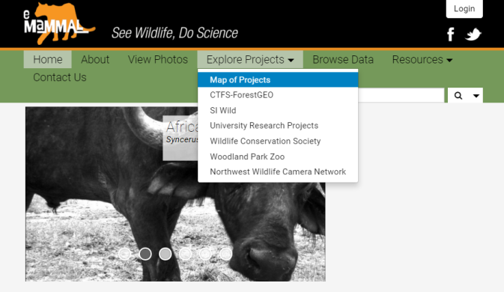

If students haven’t explored camera data before, introduce them to eMammal and camera data by having them explore some photos on <http://emammal.si.edu>. To do this, select a project from the website:

1. Explore Projects 🡪 Map of Projects
2. Some projects have sample photos linked to their descriptions for students to explore, and others do not currently have this feature. Some projects with favorite photos available are indicated by **red arrows** in the screen shots to the right.

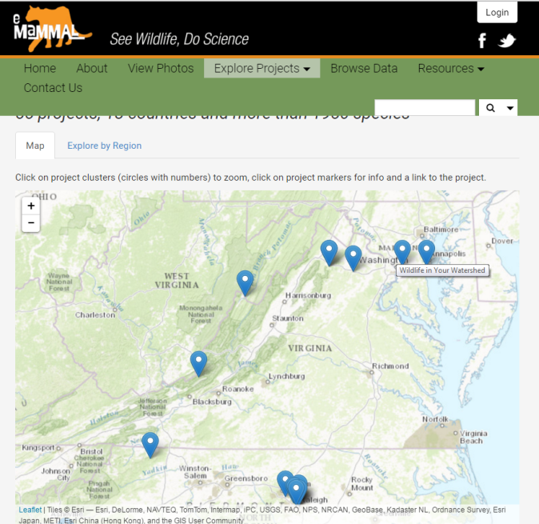

From right to left, in the image of Virginia to the right, they are: Wildlife in Your Watershed, Urban to Wild, and Recreation Effects on Mid-Atlantic Wildlife, and Stone Mountain Trail Building.

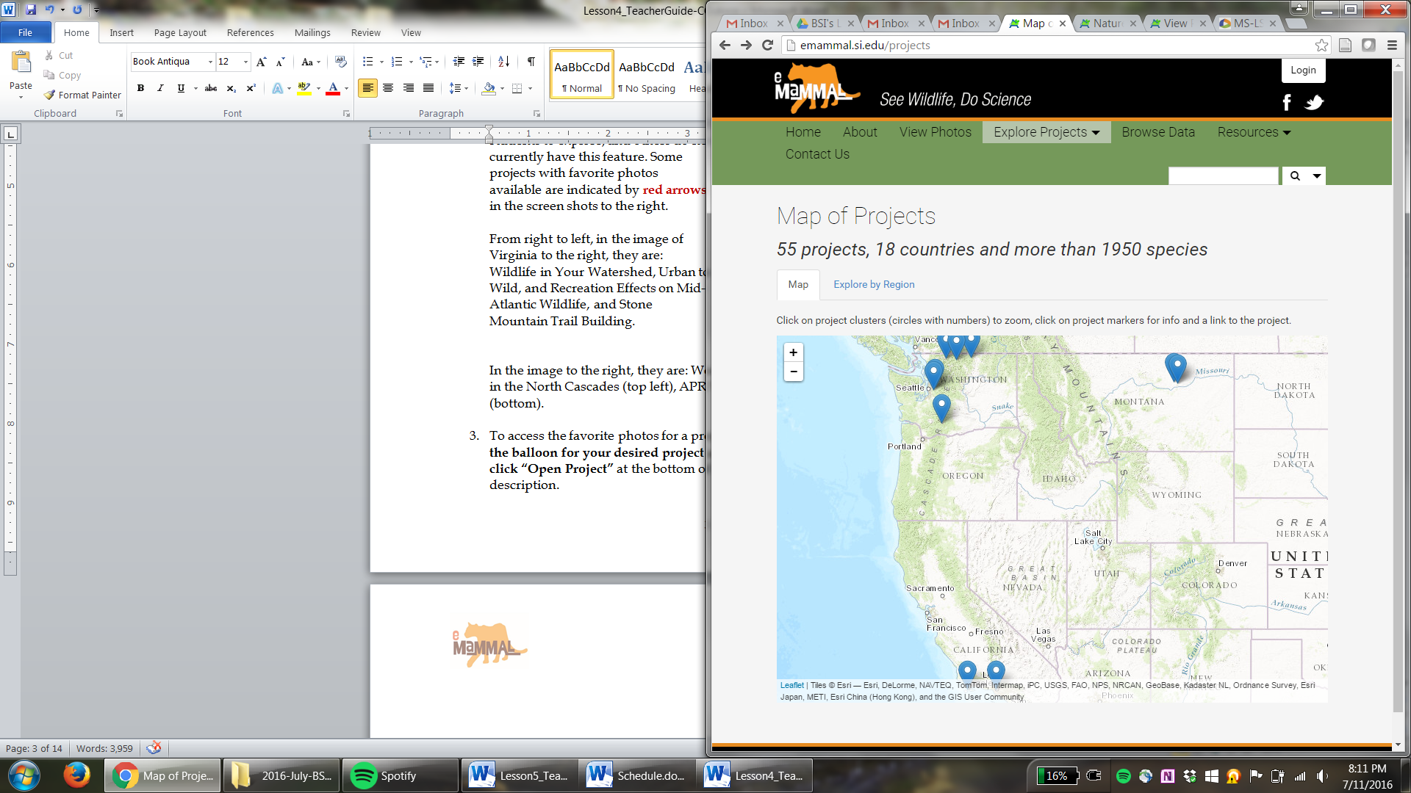

In the image to the right of the western United States, projects with favorite photos include: Woodland Park Zoo: Monitoring Wolverines in the North Cascades (top left), APR Wildlife Survey (top right), Nature in LA (bottom).

1. To access the favorite photos for a project, **click on the balloon for your desired project** and then **click “Open Project”** at the bottom of the project description.

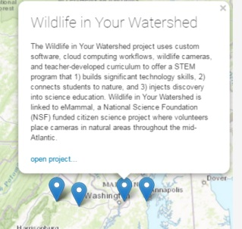

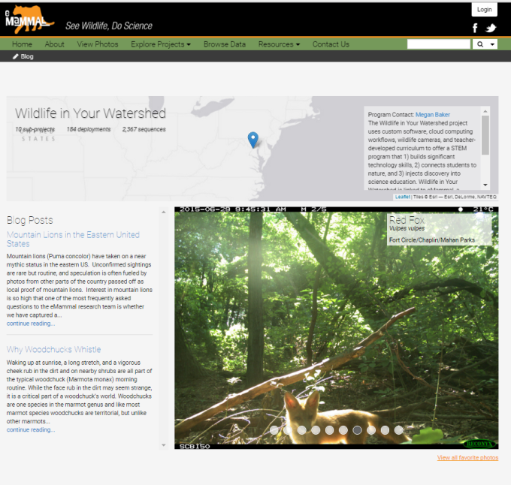4. In the new window, students can read

about their selected project, including its

goals and location. They can also see some

favorite photos. To see all of the favorites

for their selected project, they can click the

“View all favorite photos” link under the

sample photo.



***STEP 2: Quantifying Ecological Communities***

*Defining an Ecological Community*

1. If not previously covered in your class, be sure students can define an **ecological community** as *a group of populations of different species found in the same geographical area and linked by ecological processes*. A community can be defined by habitat and/or taxon, e.g. the grassland community of Yellowstone National Park might include all living organisms in that habitat, while the butterfly community of Yellowstone National Park would include only butterflies in that location. Today we’re focusing on the large mammal community living in Washington D.C. and northern Virginia.
2. How do scientists analyze a community? **Ask students what they might want to know about a community of animals living on your school grounds**. There are many things we might want to know (e.g. Which animals are here? How many of each animal are here? How many different types of animals are here? Why are they here?). These are all important questions that community ecologists ask and answer. Today we’re going to focus on:
   1. Why are animals here? This relates to a species’ **niche**, which we’ll expand on later in **STEP 3.**
   2. How many different types (species) of animals are there? **Species richness** isthe *count of how many different species are in an area*. (**Students should define species richness on their worksheet, Question 1.**)

*Estimating Species Richness*

Species richness might seem easy to calculate – you just count the species, right? While this is true, knowing exactly how many species are in an area can be harder than you think. It is easy to count the species that aren’t scared of people or are very common, but what about those that are more elusive or rare? Scientists often use **species accumulation curves** to help them figure out the number of species in their community of interest that are present and detectable with the methods they used (e.g. camera traps). A species accumulation curve is an x-y scatter plot with number of samples on the x-axis and number of species on the y-axis (Figure 1).

NOTE: Counting all species in an area requires using many different methods. A scientist using camera traps that are all deployed about 50 cm from ground level is trying to detect all species of a certain size that spend time on the ground surface. A species accumulation curve that this scientist uses to estimate species richness wouldn’t include all mammals, just those detectable by these cameras. For example, this sample wouldn’t include species like bats or moles, which are rarely found walking along a forest floor and would have to be sampled using different methods. To accurately assess total mammal species richness in an area, scientists would use cameras, nets and/or sound recorders to catch bats, and live traps, among other methods, to obtain a full estimate of species in an area. They would also need to survey at a wide variety of times and seasons, to ensure they didn’t miss any species that may be hibernating in winter or are only active at night.

**Figure 1.**

A species accumulation curve, with the x-axis labeled as number of samples and the y-axis as total species. A larger sample size provides more confidence in an estimate of species richness.

In a species accumulation curve, a “sample” is a standard unit of data collection, and is defined by the scientists for a given project. Sometimes scientists define a sample as every individual caught, while other times a sample might be a group of individuals. For example, if you are catching birds in nets and releasing them, a sample might be one morning’s catch in the net; in camera trapping, this could be one camera trap night (a 24 hour segment of a camera deployment) or the entire 21-day deployment for a single camera, with each camera serving as a sample.

Scientists use species accumulation curves to figure out if they have thoroughly sampled a community using their methods. Species accumulation curves allow scientists to know when they have likely detected all the species that they can with their methods. They can tell this when their accumulation curve levels off, and they don’t detect any new species in several samples. In the graph above, at least one new species is added to the species tally in each of the first 5 samples (i.e. species richness increases with each new sample). In the 6th, 7th and 8th samples, however, no new species are found, and so the species richness estimate levels off at 8 species. It is important to note that 8 total species were found in these 8 samples, and the graph would level off at 8 no matter if sample was labeled as 1st, 2nd, or 6th. Samples in this exercise have been put in a specific order to make the activity run smoothly and to make it easy for the instructor to double-check student answers using the key below, but the same total species richness (8) would be obtained regardless of sample order.

If we had stopped collecting data after 3 samples, could we be sure there were only 6 species in our community? Since our richness estimate increased from 3 species to 5 species from Sample 1 to Sample 2 and from 5 species to 6 species after Sample 3, it is likely that we would find a new species in sample 4, and it is important to continue sampling until we have multiple samples without any new species. The number of samples taken in a community is a way of measuring **sampling effort**.

1. In this activity, students will estimate the species richness of a northern Virginia wildlife community. Each sample is provided as 4 pictures on a single PowerPoint slide. There are 8 samples. These can be thought of as 8 different cameras deployed in northern Virginia, for this purpose. This activity can be done in a few different ways. Two options, “Small Group” and “Full Class” are listed below:
   1. Small Group Activity:

Divide your class into eight groups and provide each group with one of the sample sheets. You’ll note there are no species labels on these sheets – they will need to identify the animals. If they are not familiar with these species, they can use the field guide on iNaturalist.org to help in identification (<http://www.inaturalist.org/guides/3098>). While there are two different species of squirrel (gray and fox squirrels) and fox (gray and red) in these pictures, for this activity, they can just identify them as “squirrel” and “fox.” Each group should identify their animals and **record their species on their worksheet (Q2)**.

*Sample Key*: (those in bold are new species identified in the community)

* + - Sample 1 - Clockwise from top left: **fox, bear**, fox, **deer**
    - Sample 2 - Clockwise from top left: **bobcat, coyote**, bear, deer
    - Sample 3 - Clockwise from top left: bear, deer, **squirrel**, bear
    - Sample 4 - Clockwise from top left: squirrel, fox, deer, **turkey**
    - Sample 5 - Clockwise from top left: squirrel, bear, bear, **skunk**
    - Sample 6 - Clockwise from top left: deer, bear, fox, bear
    - Sample 7 - Clockwise from top left: fox, deer, deer, fox
    - Sample 8 - Clockwise from top left: deer and bobcat, deer, squirrel, deer

Once each group has identified their species, have a representative of Sample 1 come up to the board and write their species’ names on the board. They should have identified three species in these four pictures (fox, bear, and deer). Have the Sample 1 representative plot this data on a species accumulation graph that you have drawn on the board (this should look like Figure 2, below). **They should also draw this graph on their worksheets (Q3)**.

**Figure 2.** The species accumulation plot after one sample.

Repeat for the remaining 7 samples, having students ONLY add species that were not recorded in previous samples. The representatives of groups 6-8 can still come up and plot their data on the graph. The final graph should look like Figure 1 (page 4 of this Teacher Guide). **Have students complete their graphs (Q3) and answer questions 4, 5, and 6.**

* 1. Full Class Activity:

If you have a small class, less time, or would rather not have your students work in small groups, this activity can also be done as a full group. You can show each sample as a PowerPoint slide with a projector. Have the full group identify the animals in Sample 1, then plot the species accumulation in a similar manner to the Small Group option. Then show Sample 2 to the whole group, identify any new species, and proceed with the remaining samples, summarizing in a species accumulation curve as described in the Small Group activity.

**—DAY 2—**

***STEP 3: URBAN-TO-WILD DATA ANALYSIS***

*Getting to Know the Urban-to-Wild Data*

1. To begin, introduce students to the Urban-to-Wild data set. You can access the photos from this project at emammal.si.edu 🡪 View Photos
   1. 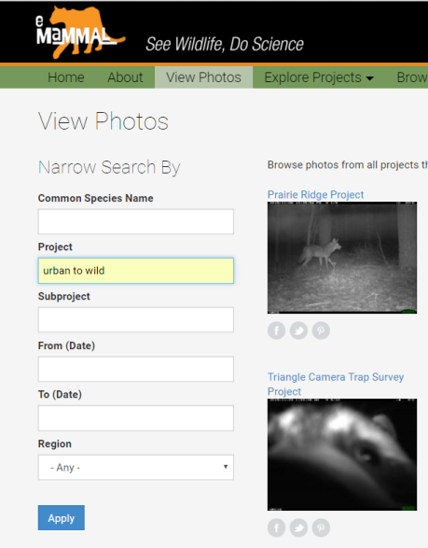Once on the “View Photos” page, type “Urban to Wild” in the “Project” box.
   2. Click “Apply.”
   3. Students can take a few minutes to explore these photos. Have them click on a few different pictures and note what information they see. For each photo, they should see the species’ common name, scientific name, the project name, and the **sub-project name**.
   4. Have them look at a few of the sub-project names. The sub-projects for this project include: **urban, suburban, exurban, rural, and wild.** What do these words mean? They are different categories of human development, defined by how densely humans live in an area. For this exercise, students just need to know that these areas are ranked from most dense (urban) to least dense (wild). If you want to share more information, we have provided information on how the scientists that designed this study defined each category below. Some students may best understand this as an average lot size for a single house (provided in football fields for a size reference students might recognize), while it might make more sense to others to think of these categories as the number of houses in a square mile. We’ve provided both descriptors below, to be used at the teacher’s discretion. Please note that suburban and exurban habitats were excluded from this class exercise (see footnote at the bottom of page 10).
      1. ***urban***

* lot size: housing lots smaller than 0.25 acres (or 1/5 of a football field…how does that work? Most cities have very tall buildings!)
* density: >1000 houses per square mile
  + 1. ***suburban***
* lot size: housing lots between 1/5 of a football field ~1 football field
* density: 147-1000 houses per square mile
  + 1. ***exurban***
* lot size: housing lots ranging from 1 to 30 football fields
* density: 12-147 houses per square mile
  + 1. ***rural***
* lot size: lots >30 football fields, mostly farmland
* density: 0.5-12 houses per square mile
  + 1. ***wild*** = protected areas with minimal human development
* density: 0-0.5 houses per square mile

1. There is a lot of data to sort through here – there are 5 pages of photos on the website, and these are just the favorites! This project collected data in 859 locations in the Washington, D.C. and northern Virginia region, each for approximately 21 days. This recorded over 12,000 animal detections. That would take us a LONG time to count, but fortunately the staff at the Smithsonian has already summarized it in a spreadsheet. **This data is available in Google Sheets at the link provided at the bottom of the ScienceLIVE site for this lesson (**[**http://science-live.org/teachers/lifeinthecity.html**](http://science-live.org/teachers/lifeinthecity.html)**)**. To make the data easy to use and understand, we are only going to focus on **urban**, **rural**,and **wild** sites today.*
2. **Have students open the spreadsheet*.** You will see the 18 species of wild mammals and large birds found at 30 urban, 30 rural, and 30 wild sites in Washington D.C. and northern Virginia. The numbers next to each species represent the number of times a species was detected in each habitat. The goal for this part of the lesson is to explore differences in wildlife communities in each habitat type. We will do this by looking at species richness, common species, and unique species.

*About the Data: The creators of this lesson excluded suburban and exurban sites from this activity to streamline this exercise and keep the quantity of data manageable for a middle or high school classroom. To ensure comparable data sets, the creators of this lesson randomly selected 30 wild sites and 30 rural sites from the Urban-to-Wild data set. Due to prior sampling in Washington, D.C. for other projects, there were only 10 urban sites in this data set, so 20 additional sites from previous eMammal projects in Washington, D.C. were added to provide sufficient sample size for comparison to the wild and rural categories. The data seen in the provided spreadsheet were generated from the raw output from the eMammal website using PivotTables in MS Excel.

*Calculating Species Richness*

1. To determine how many species are present at each site, we can count by hand, or let Excel/Sheets do the work for us. Why not the latter? The key to success here is to demonstrate how to do this on a computer connected to a projector, so students can see how it is done before trying it themselves.
   1. While adding up each column using the SUM function might be tempting, it is important to remind students of our goal, which is number of species, not number of animals. To get number of species, we need to count, rather than add. In this case, we want to count any species that has a value greater than zero, as any non-zero number means the species was present. We can get Excel/Sheets to do this for us using the COUNTIF() function, as follows:
   2. **In the cell next to species richness (cell C21), type =COUNTIF(C2:C19,”>0”)**. In this formula, C2:C19 represents the cells you want Excel/Sheets to count, and “>0” represents the conditions in which you want it to count a cell.

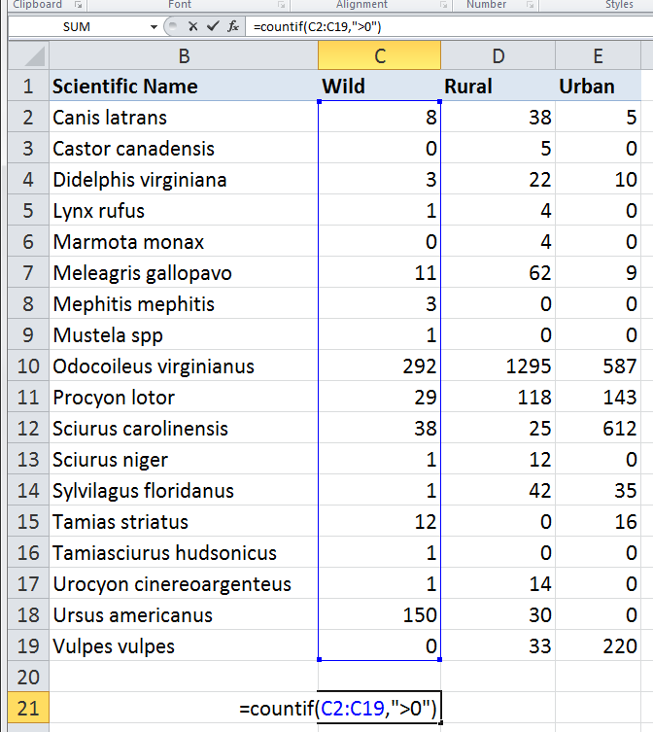

* 1. Once the formula is entered, hit return/enter and you should get an answer of 15 species in the wild environment.
  2. This can be repeated for rural and urban, referencing cells D2:D19 and E2:E19, respectively. **Have students record these numbers on their worksheet (Q7).**

**KEY to Student Worksheet Question 7**

|  |  |  |  |  |
| --- | --- | --- | --- | --- |
| **Habitat** | **Richness** | **Most Common Species** | **2nd Most Common Species** | **Unique Species?** |
| Urban | ***9*** | ***gray squirrel*** | ***white-tailed deer*** | ***none*** |
| Rural | ***14*** | ***white-tailed deer*** | ***raccoon*** | ***beaver, groundhog*** |
| Wild | ***15*** | ***white-tailed deer*** | ***bear*** | ***striped skunk, weasel, red squirrel*** |

*Common and Unique Species*

1. Along with species richness, we can use **relative abundance** to determine habitat preferences among species. For example, gray squirrels are present in all three habitats, but are clearly most abundant in densely populated areas, as evidenced by their higher relative abundance in urban (612 individuals) versus rural (25) and wild (38) areas. **Have students record the most common and second most common species in each habitat on their worksheet (Q7). They should also answer Question 8**, which prompts them to think about why relative abundance varies across habitats.
   1. In question 8, try to get students thinking about different life history traits
2. On the other end of the relative abundance spectrum are very rare species, which are in low numbers and only found in one habitat type. Sometimes, for very low abundance species, finding one individual in a habitat and none in the others is due to randomness, but sometimes they are found in that habitat for a reason. **Prompt students to scan the data for species only found in one habitat type, enter this in Question 7’s table, and then answer Question 9, which asks them to think about why those species were found where they were.**

*Species’ Niches and Urban Life*

As you could see in 7-9, some animals have an easier time living near humans than others. This has to do with a **species’ ecological niche**, or its *role in an ecosystem, including its interactions with other species and its environment*. **(Students should define a niche on their worksheets [Q10])**.

1. Niches are defined by many factors, including what a species eats, where it lives, and what it needs to survive. Today we’re going to focus on the aspects of the species’ niche that most affect their ability to live with humans. **Explain home range, body mass, and litter size to students. Then, on their worksheets, students are prompted to think about how these factors affect a species’ ability to live in the city.** Some ideal answers are below:

* **Home range** size is how much space an animal needs to live. Given the typical lot size and human density in the city, animals with larger home ranges will have a harder time with urban life.
* **Body mass** is the weight of an animal. Due to the resources it takes to maintain a larger body mass, animal size and home range size often go hand-in-hand, and, consequently, larger animals are usually less likely to be found in a city.
* **Litter size** is how many babies an animal has each time they reproduce. The more fecund (reproductively successful) a species is, the more adaptable it usually is, so higher litter size often benefits a species trying to live in a city.

1. 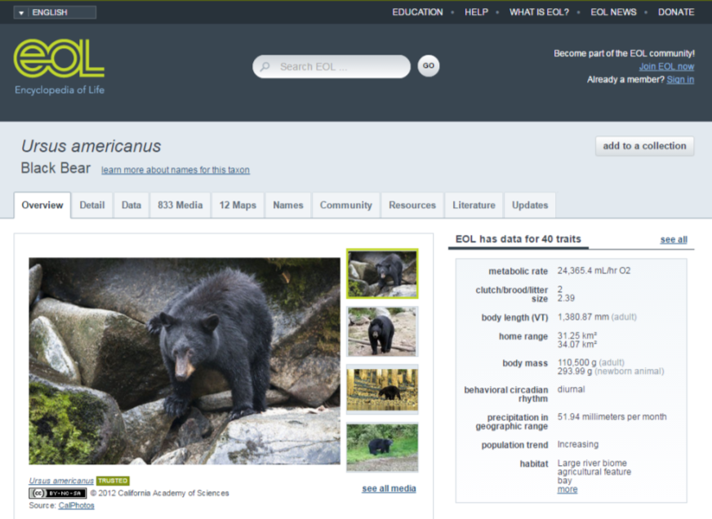To reinforce the concept of life history traits that help species adjust to city life, **have students search for litter size, home range, and body mass of the black bear (*Ursus americanus*) and red fox (*Vulpes vulpes*) on the Encyclopedia of Life website (eol.org).** On the website, these data are found in the top right corner of each species’ profile. In some cases, a range of values is given. **To keep things simple, have students pick the higher number provided for each trait and record that value on their worksheets (Question 12).**

**KEY to Student Worksheet Question 12**

|  |  |  |  |
| --- | --- | --- | --- |
| **Species** | **Litter Size** | **Home Range** | **Body Mass** |
| Black Bear | **2.39** | **34 km2** | **110,500 g** |
| Red Fox | **5** | **3.5 km2** | **4580 g** |
| Which is bigger? | **fox** | **bear** | **bear** |
| How many times bigger? | **2.5** | **9.7** | **24** |

1. Using the “Making Bar Graphs in GoogleSheets” handout, have students graph bear and fox abundance in wild, rural, and urban habitats. They will find that bears are most common in wild habitats, likely due to their large body and home range sizes and small litter size. Red foxes, on the other hand, are most common in urban landscapes, likely due to their larger litter size and smaller home range and body sizes.
2. As a final assessment of student learning, students can be assigned a short essay on urban wildlife. Prompts for this essay are listed at the end of the student worksheet.